

Regalo
Functional Requirements Document

Version | Description of Change | Author | Date
0.1 | Regalo Functional Document | Tarun Mallampalli | 09-June-2018

CONTENTS
1 INTRODUCTION 4
1.1 Purpose 4
1.2 Scope 4
1.3 Background 4
1.4 Users For Our Application 4
2 METHODOLOGY 4
3 FUNCTIONAL REQUIREMENTS 4
3.1 User Perspective ................................................................................................5

3.1.1 Data Flow Diagram ........................................................................................5

3.2 Vendor Perspective ...........................................................................................6

3.2.1 Data Flow Diagram ........................................................................................6

3.3 Admin Perspective ............................................................................................6

3.3.1 Data Flow Diagram ........................................................................................6

INTRODUCTION

Our Regalo Application will gift a person on their special/particular days only.

Purpose

If We are planning to give a gift to a person who was not nearer to us . Currently we are ordering in the online and giving the delivery address of that particular person. And that gift will be delivered to them too early or late.

Scope

By using Regalo user will purchase the product(Gift) and selects the delivery address and date of delivery. We will deliver the gift to that person on that day (Which was selected by the user).
We will deliver the gift to that person in the place of the user who booked the gift.

Background
We have to develop this application completely from developing front end responsive web pages , server side code with database connections and code deployment.

Users For Our Application

Our Regalo Application was used by 3 different types/roles of users .

Admin : Who will manage all the users and gifts/products details.

User : Who will just purchases the gift .

Vendor : Who will register with our application and keeps their products with price and description.

METHODOLOGY
We Will follow the Jira Boards for project management and Agile Methodology .

FUNCTIONAL REQUIREMENTS

While opening our application it will launch the application index page where we will describe about the application.
On the header part we will keep Login/Sign-up button. For Sign-up
We will ask as an User/Vendor.

3.1 User Perspective

- User will register with our application and login.
- Once User logged in successfully then they will be navigated to Home Page.Where he can see the list of gifts. On the Menu page he/she can select the My Account drop-down button to check My Orders(Order History) and Account Details(Password Change Etc).
- From the main page user will select any item and proceed to delivery address page.(Here user has to give Beneficiary name , Type of Occasion, Date Of Delivery and address).
On the same page right side a virtual greeting card is present user can edit the message on the card. (That card will be given to the beneficiary with the gift )
- Next We will proceed to the Payment.

3.1.1 Data Flow Diagram

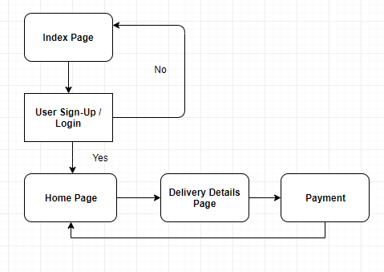

3.2 Vendor Perspective

- Vendor will register with our application and login.
- Fills the form and upload the item image, price, quantity and description and submits the form.
- That details will be verified by the Admin. If admin approves the item then they can sell the items.
- In the dashboard they can seen the how many orders they received and full filled.

3.2.1 Data Flow Diagram

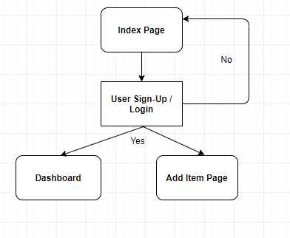

3.3 Admin Perspective

- For Admin there will be separate page (URL) to login .
- Once he was successfully logged in they will open a dashboard and see no of orders received today.

- He can select Menu For Users(Update / Delete User) and Vendors(Update or delete and approve the request from the vendors).

- Daily in the morning 6:30 admin should receive the mail (All the Orders Report of the previous day) .

3.3.1 Data Flow Diagram

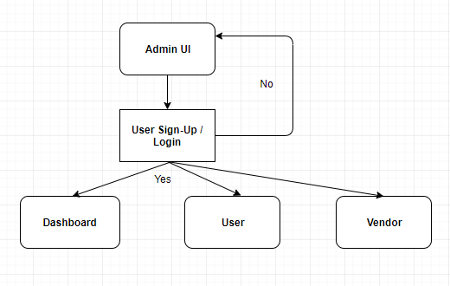
-- The End --

